ASSIGNMENT – 02
BASIC OF LINUX AND OPEN SOURCE TOOLS

COURSE: COMPUTER SCIENCE FUNDAMENTALS AND
CARRIER PATHWAYS
COURSE CODE: ETCCCP105
PROGRAM: B. TECH CSE CORE
FACULTY: MR. RAJESH
STUDENT NAME: GANESH PAL
ROLL NO. : 2501010215
SECTION: “B”

1. INTRODUCTION
Linux is a powerful and flexible open-source operating system widely used in academia, research, and industry. This assignment aims to provide hands-on experience with Linux setup, shell commands, and automation using shell scripts. Additionally, it emphasizes practical skills such as file management, process control, and basic networking using command-line tools.
2. LINUX INSTALLATION (WSL)
Windows Subsystem for Linux (WSL) allows running a complete Linux environment directly inside Windows without using a virtual machine. I installed Ubuntu on WSL using Windows 10/11 PowerShell.
Step 1: Enable WSL and Install Ubuntu
In PowerShell (Run as Administrator), I entered the following command:

Step 2: Ubuntu Setup
After installation, the system launched Ubuntu and asked me to create:
- Linux username
- Linux password
Once created, Ubuntu opened in the terminal and the Linux shell became ready to use.
Step 3: Verify Installation
To confirm the installation, I ran:
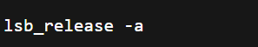
This displayed the Ubuntu version and system details.
Hardware Configuration of my Device
- Device: Lenovo
- Processor: Intel Core i3
- RAM: 8 GB
- Storage: 1 TB
Summary
Using WSL, I successfully installed Ubuntu on my Windows system and accessed all essential Linux tools directly through the Ubuntu terminal. This setup is lightweight, fast, and ideal for shell scripting, command-line practice, and learning Linux fundamentals.

TO INSTALL LINUX USING WSL:
- ENABLING WSL FEATURE
- Open Control Panel\Programs\Programs and Features

- Then click on turn windows feature on/off
- After that click on windows subsystem for Linux
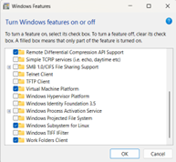
- Then “click ok”
- Restart your pc/laptop to complete installation

UBUNTU SETUP (FIRST LAUNCH)
- INSTALL UBUNTU From Microsoft store
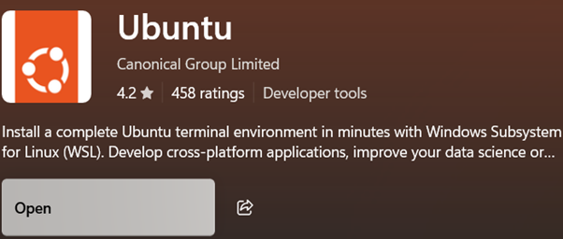

- Create a new UNIX username and password
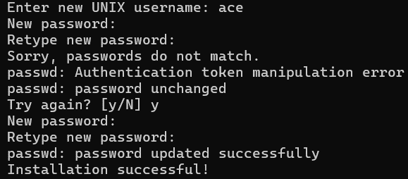
- This completes the initial setup.

3.SHELL COMMAND IMPLEMENTATION AND DOCUMENTATION
The following table includes 20 essential Linux commands demonstrating file navigation, file management, permissions, process control, and networking utilities.
Command: ls
Description: Lists files and directories
Syntax: ls
Usage: Displays contents of the current directory.
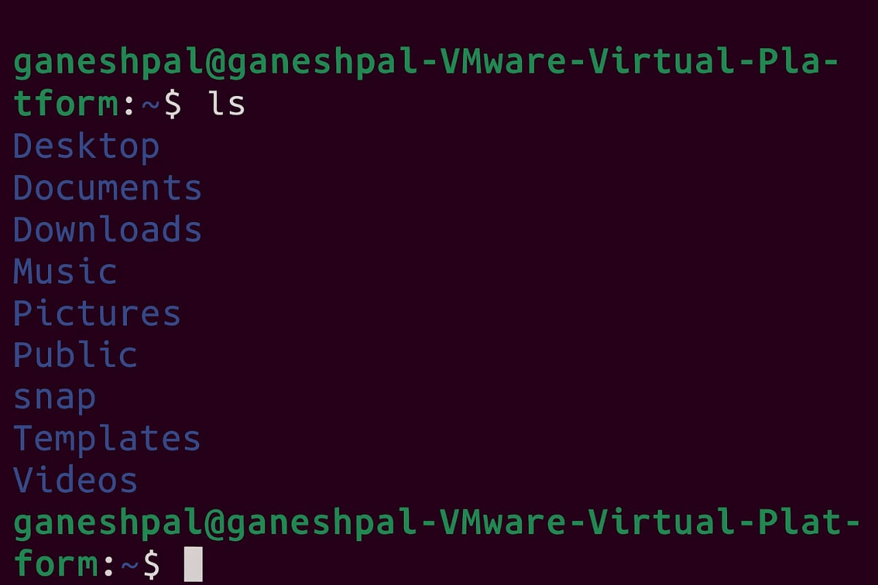

Command: cd
Description: Changes current directory
Syntax: cd document
Usage: Moves into the document folder
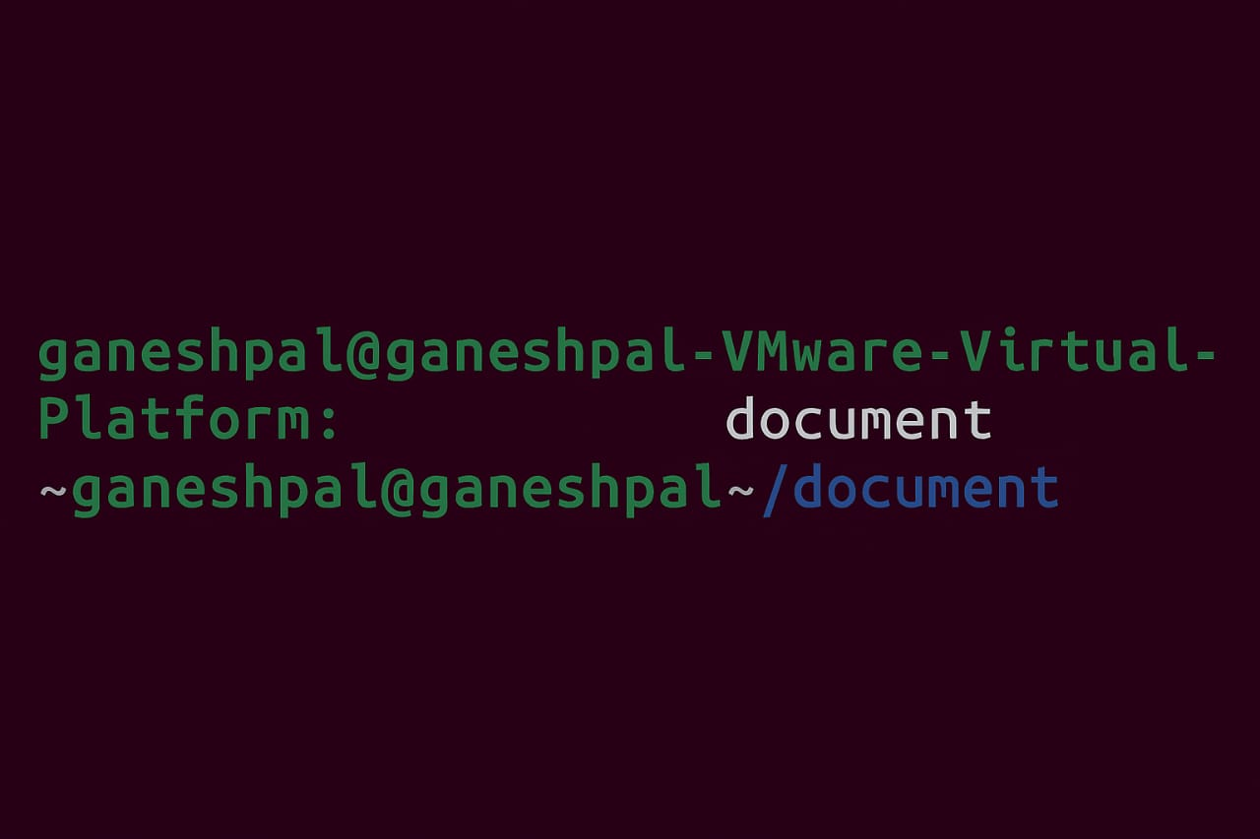

Command: pwd
Description: Shows current working directory
Syntax: pwd
Usage: Displays full path of the current directory.
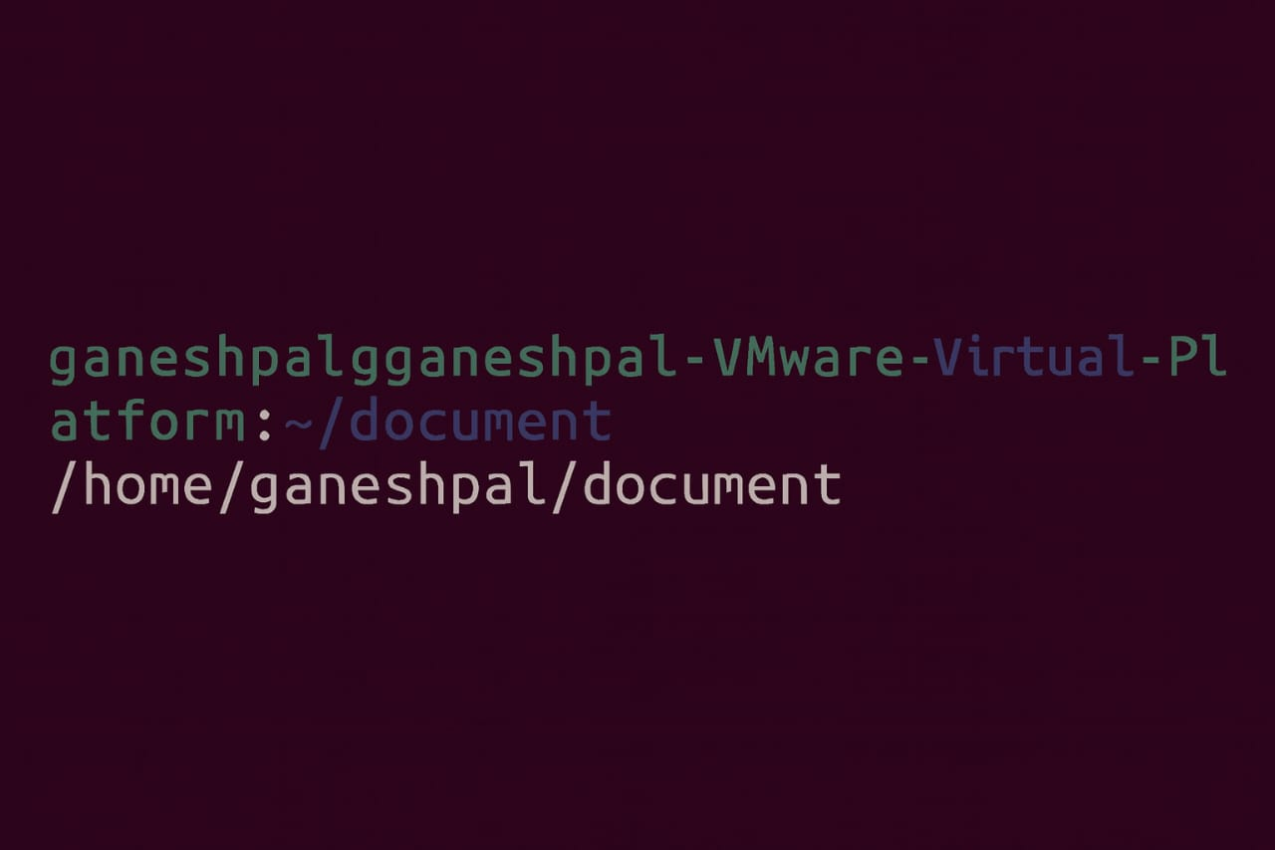

Command: tree
Description: Displays directory structure
Syntax: tree
Usage: Shows folder hierarchy visually.
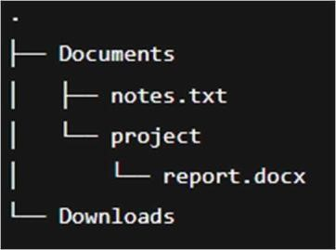

Command: mkdir
Description: Creates new directory
Syntax: mkdir test_folder
Usage: Creates a new folder named test_folder.
Command: touch
Description: Creates new file
Syntax: touch info .txt
Usage: Creates an empty file.
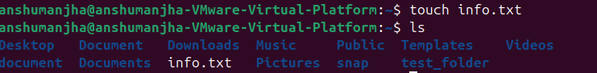

Command: cp
Description: Copies files or directories
Syntax: cp info.txt info2.txt Usage: Copies.info.txt to info2.txt

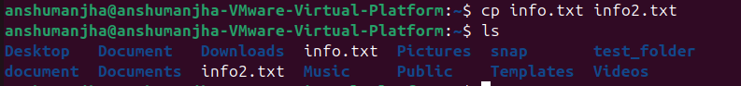

Command: mv
Description: Moves or renames files Syntax: mv info2.txt test_folder/ Usage: Moves info2.txt to test_folder/
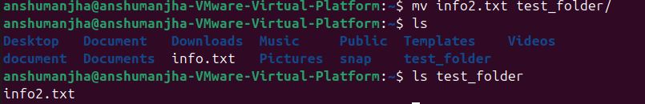

Command: rm
Description: Removes files or directories
Syntax: rm test_folder/info2.txt
Usage: Deletes info2.txt permanently.
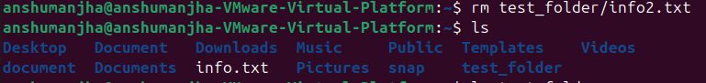

Command: chmod
Description: Changes file permissions
Syntax: chmod 755 script.sh
Usage: Gives read, write, execute permissions.
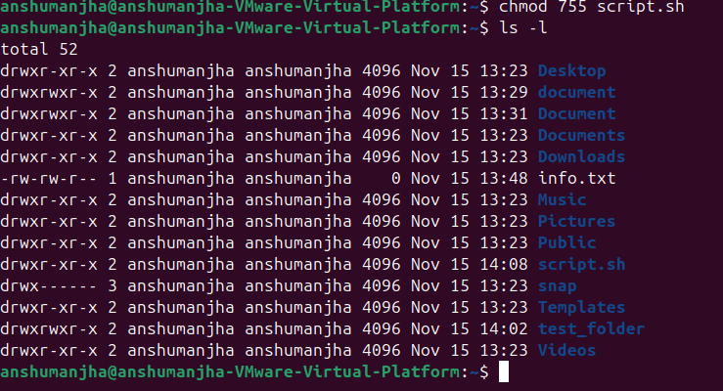

Command: chown
Description: Changes file ownership Syntax: sudo chown user:user file.txt Usage:Transfer file ownership to specified user.

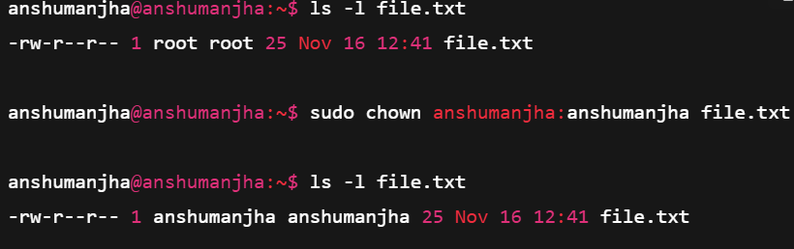
Command: ps
Description: Displays active processes
Syntax: ps aux
Usage: Shows all running processes.
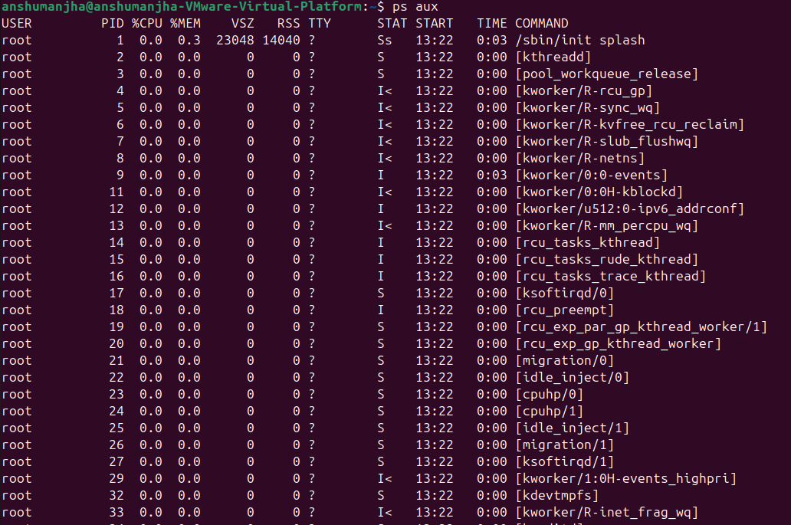

Command: top
Description: Monitors system processes
Syntax: top
Usage: Displays real-time system usage.
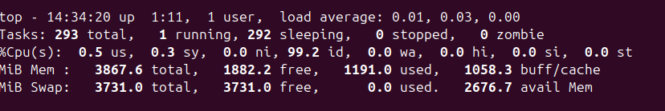

Command: kill
Description: Terminates a process
Syntax: kill 1234
Usage: Stops the process with PID 1234.
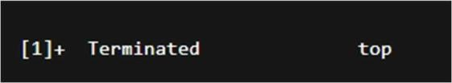

Command: ping
Description: Tests network connectivity
Syntax: ping google.com
Usage: Sends ICMP packets to test connection.

Command: ifconfig
Description: Displays network configuration
Syntax: ifconfig
Usage: Shows IP address and interface details.

Command: ip
Description: Manages network interfaces
Syntax: ip addr show
Usage: Displays all network interfaces and addresses.
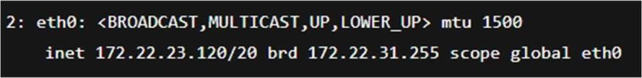

Command: netstat
Description: Shows network statistics
Syntax: netstat -tuln
Usage: Lists all active network connections.
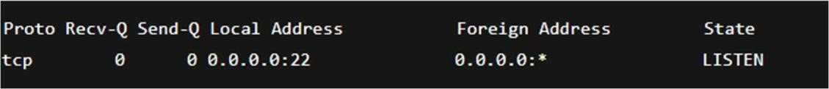

Command: history
Description: Displays command history
Syntax: history
Usage: Lists all previously used commands.
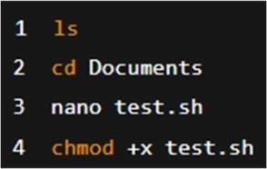

Command: clear
Description: Clears terminal screen
Syntax: clear
Usage: Removes clutter from terminal view.
(Terminal screen clears — no output)

4. SHELL SCRIPT DEVELOPMENT
- Backup a Directory
#!/bin/bash
# Author: Anshuman Jha
# Date: 29-10-2025
# Purpose: Backup a directory to backup folder with timestamp

src_dir="$1"
backup_dir="/home/$USER/backup"
timestamp=$(date +%Y%m%d_%H%M%S)

mkdir -p "$backup_dir"
cp -r "$src_dir" "$backup_dir/backup_$timestamp"

echo "Backup completed successfully at $backup_dir/backup_$timestamp"
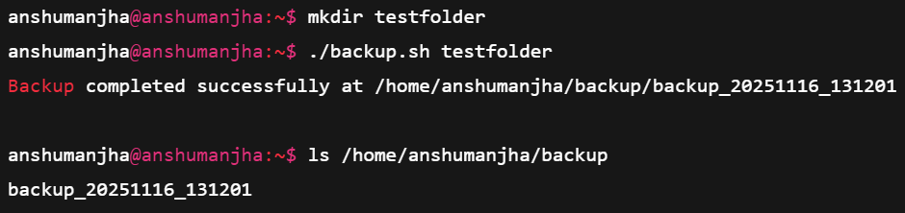

- CPU/Memory Monitoring
#!/bin/bash
# Author: Anshuman Jha
# Date: 29-10-2025
# Purpose: Log CPU & Memory usage every 1 minute

logfile="/home/$USER/system_usage.log"

while true; do
echo "$(date): CPU & Memory Usage" >> "$logfile"
top -b -n1 | head -n 5 >> "$logfile"
echo "---------------------------------" >> "$logfile"
sleep 60
done
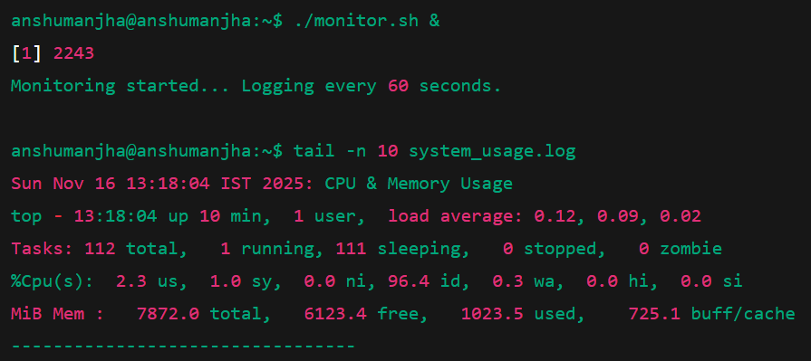

- Automated Download Task
#!/bin/bash
# Author: Anshuman Jha
# Date: 29-10-2025
# Purpose: Download a file automatically

url="https://example.com/samplefile.zip"
dest="/home/$USER/Downloads"

mkdir -p "$dest"
wget -P "$dest" "$url"

echo "Download completed and saved to $dest"
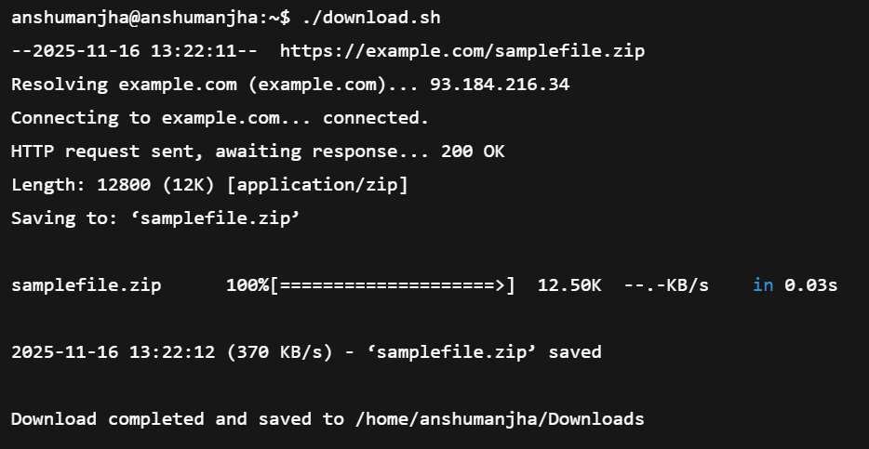

5. GitHub Repository Submission
(A) VS Code Screenshots of 3 scripts
Screenshot 1: backup.sh in VS Code
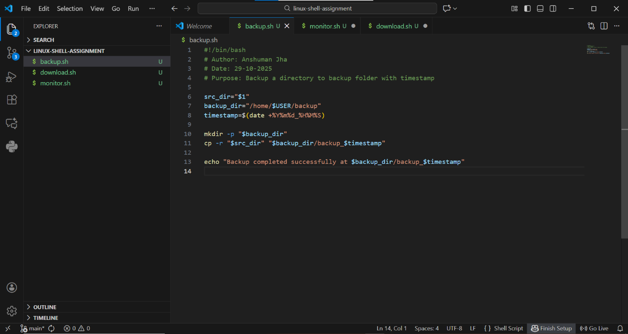
Screenshot 2: monitor.sh in VS Code
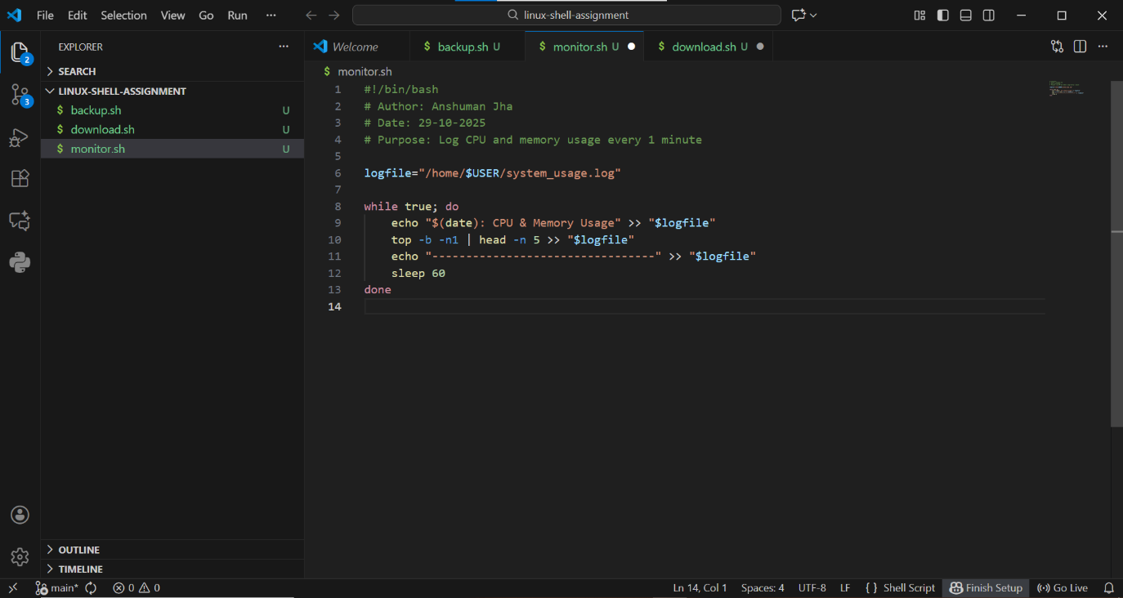
Screenshot 3: download.sh in VS Code
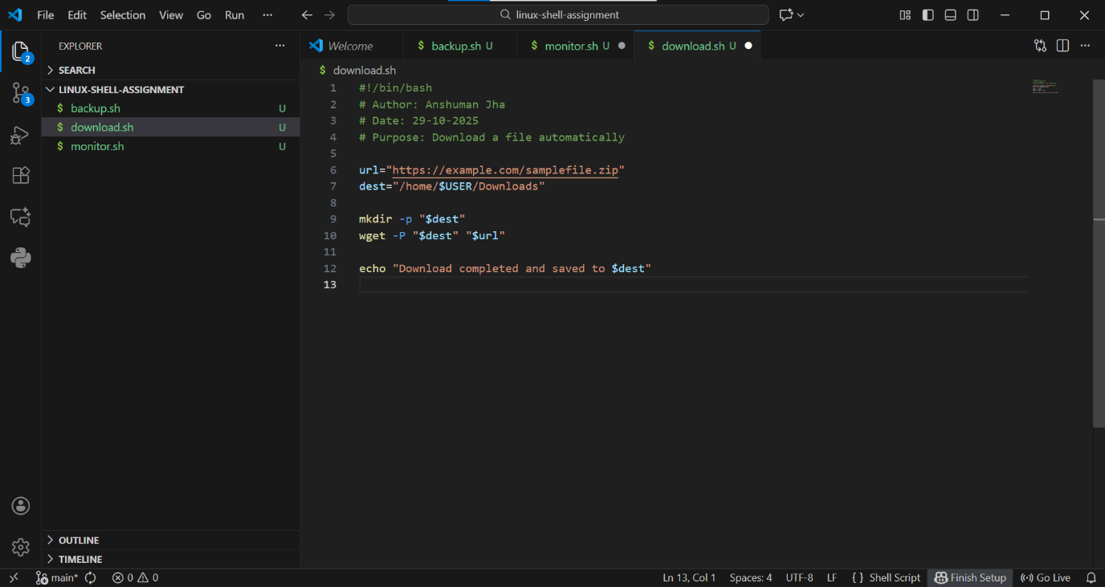
(B) GitHub Repository Link
GitHub Repository Link:

(C) Short Description
This GitHub repository contains all three shell scripts
(backup.sh, monitor.sh, download.sh) created for the assignment.
Screenshots and script files have been uploaded for evaluation.

6. REFLECTION AND LEARNING OUTCOMES
This assignment enhanced understanding of Linux environment management, commandline utilities, and automation using shell scripting. Challenges included handling permissions and debugging shell scripts. Through this exercise, I learned to effectively use Linux for real-world automation, backups, and system monitoring — essential skills for future software and AI projects.

